API DOCUMENT

Product Requirements Document (PRD) / Software Requirements Specification (SRS)
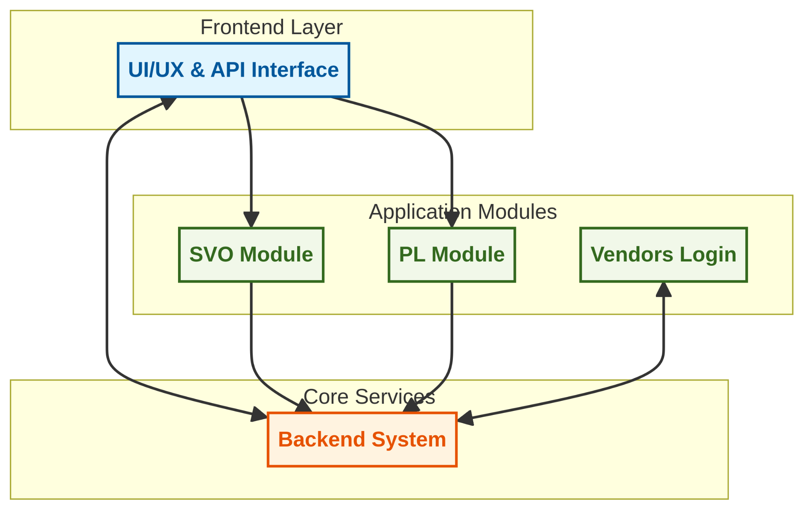

1. Product Overview
Product Name: Auto Parts Ordering & Fulfillment Platform
Objective: Digitize and streamline auto parts purchasing, inventory visibility, order fulfillment, and delivery coordination between vehicle owners, vendors, and logistics partners.

UI/UX & API Architecture
Auto Parts IND Platform

- 1.Application Overview

The Auto Parts IND application is a vehicle-parts discovery and purchase platform with
logic-driven UI/UX to ensure user safety, correct part usage, and reliable sourcing.
The system operates with two distinct logins:
1. Vehicle Owner (VO)
2. Partner Login (PL)( Partner Login: Mechanics, Garage Owners, Service Centres)
Both logins access the same underlying parts database but experience different UI behaviours,warnings, and pricing structures.

Vehicle owner (VO) | Partner Login (PL)
User Definition  An VO is:  - An individual vehicle owner  - Not a professional mechanic or service provider  - Expected to have limited technical expertise  The UI is designed to guide, warn, and protect the user during part selection and installation. | User Definition  Partner Login includes:  - Mechanics  - Garage owners  - Service centers  These users are considered professionally qualified to handle vehicle components.
Component Stamping System (VO Only)  Each component visible to an VO is assigned one of two stamps:  1. SELF FIX (Do It Yourself) Stamp  - Indicates the component can be safely installed by the user  - No professional tools or high-risk operations involved  UI Behavior:  - SELF FIX stamp clearly visible on product card and product page  Content Access:  - A video clip is provided explaining:  - What the part is  - How to fix/install it yourself  2. Mechanic Required Stamp  - Indicates professional installation is recommended  - Involves safety, calibration, or technical complexity  UI Behavior:  - Stamp displayed on product card and product page  Checkout Behavior:  • • A cautionary message is shown at checkout before purchase confirmation | UI & Feature Rules (PL)  For Partner Login:  - No component stamps  - No cautionary messages at checkout  - No SELF FIX instructional videos  The UI is optimized for:  - Speed  - Bulk or frequent purchases  • • Professional familiarity
Mechanic Required – System Suggestions  For components stamped Mechanic Required, the system provides two suggestions:  - Suggest Nearest Garage  - Displays nearby garage options relative to the user’s address  - Suggest Nearest Available Mechanic  - Allows the user to place an order for a mechanic to visit the address  These are suggestions only and do not block part purchase. | Pricing (PL)  - Partners receive 30–40% lower pricing compared to market  - Pricing advantage reflects:  - Professional usage  - Volume potential  - Trade relationship  Pricing is shown directly without comparisons or warnings.
Pricing (VO)
- VO users receive prices 10–12% lower than market price
- Discount is visible at the product and checkout level
- No negotiation or tiering logic exposed in UI

User Journey (VO)
The VO journey is structured to allow:
- Browsing
- Part discovery
- Education (SELF FIX video)
- Safe decision-making
- Purchase
High-Level Flow:
- Login
- Vehicle identification (via VRN)
- Browse or search parts
- View stamp (SELF FIX / Mechanic Required)
- Watch video (SELF FIX only)
- Review cautions (if applicable)
- Checkout and purchase

Common Features (VO & PL)
The following features are shared across both logins:
1. Vehicle Identification via VRN
- Users can fetch vehicle-compatible parts using Vehicle Registration Number (VRN)
- VRN-based lookup filters incompatible parts
Outcome:
- Reduced incorrect purchases
- Faster part discovery
2. UI-Based Part Classification
Parts are grouped into the following categories across the application UI:
- Maintenance Parts
- Oils & Lubricants
- Lights
- Filters
- MODEX
  - Exotic modifications
  - OEM modifications
These classifications are visual and navigational, not role-dependent.

Product Logic Summary
Feature | VO | PL
Component Stamps | Yes | No
SELF FIX Videos | Yes | No
Checkout Caution | Yes (Mechanic Required) | No
Garage / Mechanic Suggestion | Yes | No
Market Discount | 10–12% | 30–40%
VRN-based Part Filtering | Yes | Yes

3. User Roles & Access Levels

Vehicle Owner (VO)
- Browse/search parts
- Place purchase orders
- Track order status

Vendor Login
Store Owner (SO): Auto parts retailer / wholesaler
Petrol Bunk Owner (PBO): Engine oil & lubricant supplier
- Manage inventory
- Accept/reject orders
- Generate DOT

Admin
- Full ERP access
- Analytics and system monitoring

4. Purchasing Order Forms

Traditional Cart System
- In-app part selection
- Quantity-based checkout
- Real-time pricing & stock validation

Written List (Image Upload)
- User uploads handwritten part list image
- Vendor manually verifies and converts to order

AI Chatbot (Call / Chat)
- Voice or chat-based order capture
- Converts request into structured purchase order

5. Functional Requirements

User Application (VO)
- Part search (by name, vehicle, category)
- Order placement
- Order tracking (confirmed → packed → out for delivery → delivered)

Vendor ERP Dashboard
- Inventory count (per SKU)
- Total sales (daily / weekly / monthly)
- Parts sold breakdown (category-wise)
- DOT (DELIVERY Order Ticket equivalent for packing)
- Low-stock alerts

Design Requirement
- Inventory must be identifiable at a glance
- No complex stock tables by default
6.ERP Behavior
- Parts shown with:
  - Available count
  - Sold count
- Visual emphasis on low remaining quantity
The goal is quick recognition, not data analysis.
DOT (Delivery Order Ticket) – Delivery Preparation Intimation
DOT Trigger
When an order is placed:
- Vendor receives a DOT-style intimation
- This acts as a preparation instruction for delivery
DOT Includes:
- Order ID
- Part name(s)
- Quantity
- Delivery type (pickup / courier)
- Time sensitivity (if applicable)
DOT exists to:
- Reduce preparation delays
- Avoid missed orders
- Create a clear handover point to delivery partners
Low Stock & High Demand Intimation
Low Stock Intimation
The system provides an alert when:
- Part quantity falls below a defined threshold
Purpose:
- Prevent last-minute stock-outs
- Enable restocking decisions
High Demand Potential Intimation
The system also provides intimation when:
- A part is selling frequently
- Demand trend is rising relative to current stock
This intimation is informational, not predictive automation.
Purpose:
- Help vendors prioritize restocking
- Highlight fast-moving parts
Admin View (ERP)
Admin can:
- View vendor dashboards
- Monitor total sales across vendors
- Track part movement across the system
- Observe low-stock and high-demand signals
Admin access is observational and supervisory, not intrusive.

System Scope Clarification (Non-Features)
This ERP does not aim to:
- Replace full accounting software
- Provide advanced forecasting
- Perform automated purchasing
- Offer complex BI dashboards

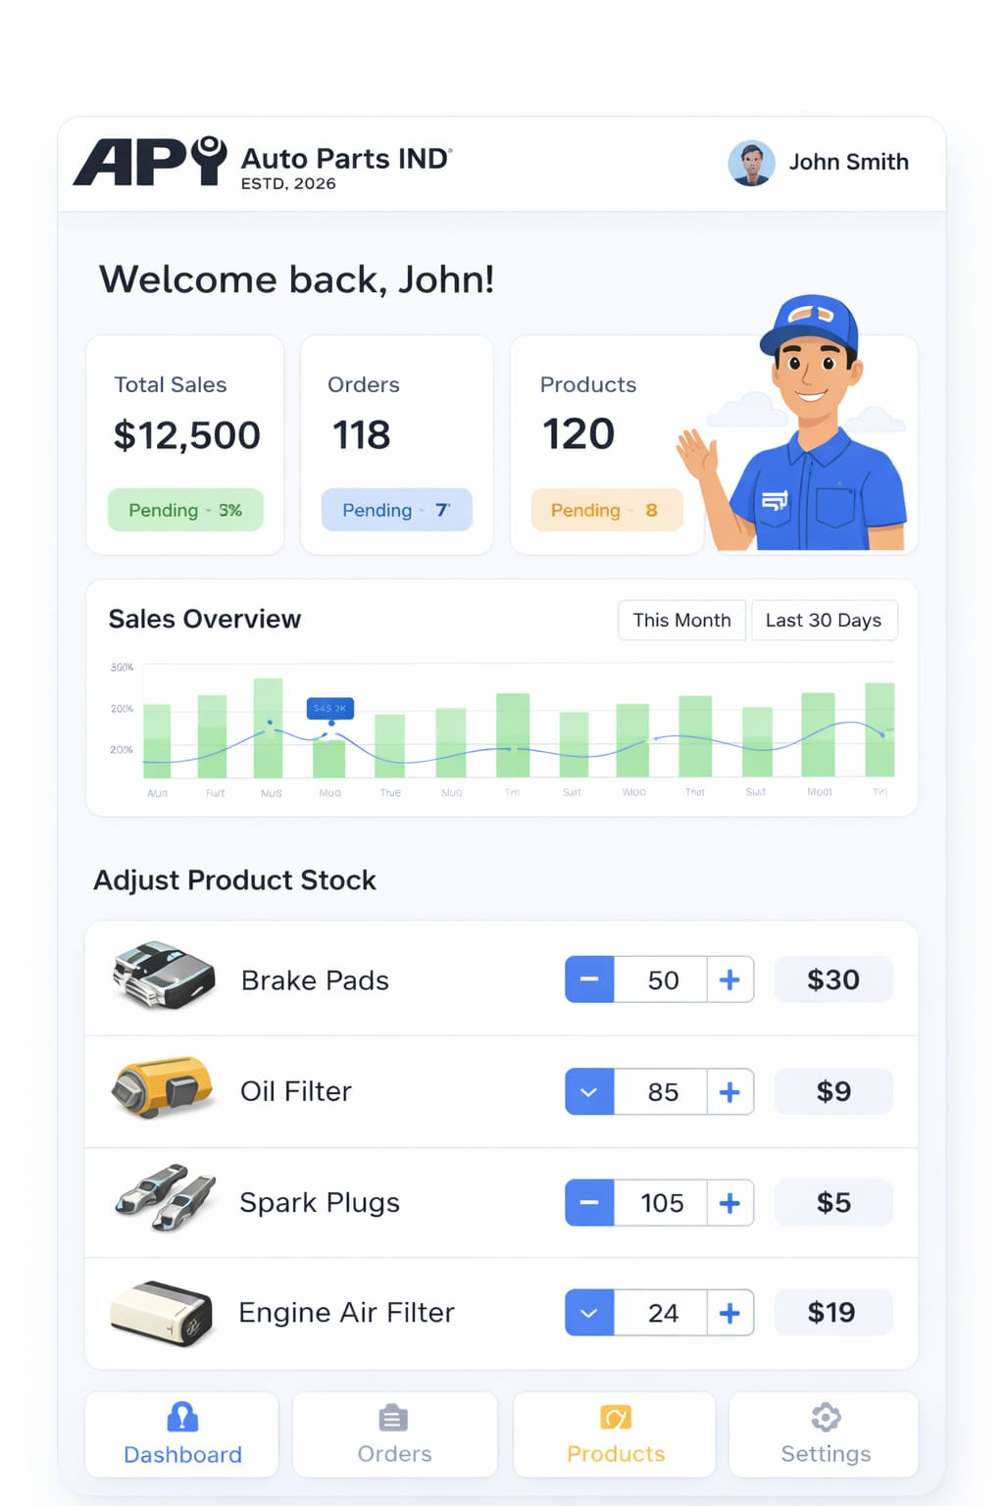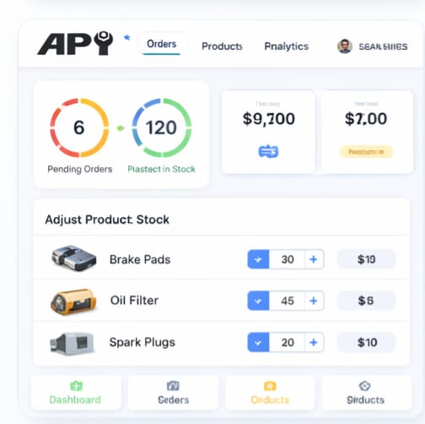

Admin Panel
- Vendor management
- Platform-wide sales metrics
- Delivery partner monitoring

7.Non-Functional Requirements
- Simple, low-latency UI
- Mobile-first responsive design
- Role-based access control
- Secure authentication
- Data retention

JIRA-READY TASK BREAKDOWN

EPIC 1: Authentication & Roles
- Implement OTP-based login
- Role-based access control

EPIC 2: VO Application
- UI for part search
- Cart & checkout flow
- Order tracking screen

EPIC 3: Vendor ERP
- Inventory management UI
- Sales dashboard
- DOT generation module
- Alert system (low stock & high demand)

EPIC 4: Admin Panel
- Vendor onboarding flow
- Analytics dashboard

EPIC 5: Integrations
- Delivery partner assignment
- Order status webhooks

In-app feedback loop (Google Forms → product iteration)

